# Here2Help – Chat Assistant for College Students

# for Frequently Asked Questions

**My AI Web based Chat Bot for college students aims to address various repeated questions that both current and prospective students have.**

## About My team

I am presently pursuing BSc-IT from St. Xavier's College Mumbai, India. I was a volunteer in the Computer Department of the annual fest of St. Xaviers College, Malhar 2021 and was responsible for maintaining accessibility standards for Malhar 2021 Website.

I have recently completed internship from Microsoft Future Ready Talent Program. I have also completed Microsoft AZ 900 and the AI 900 Certification.

I am visually Challenged and have Low Vision and am interested in working on Accessibility and making user experiences Inclusive for All.

## The Concept

When I joined Senior College, I found it difficult to get answers to simple questions in the online world as I was not familiar with the college website. I explored few other college websites and observed that most websites do not have a proper FAQ page. In today’s world there are new modes of user interaction aided by Artificial Intelligence and I think an **FAQ** would help in addressing the various repeated questions that both current and prospective students have.

This project is aimed to implement a **web based ChatBot** with the help of various Azure Services to assist students. This bot which would help communicate in natural language with the users and help them answer the various common questions that students have automatically. Also, since I am a visually impaired person, I have focused on making the solution **accessible** to all users.

## Target Audience or Market

My AI Web based Chat Bot for college students aims to address various repeated questions that both current and prospective students have.

### Personas

* A prospective student usually explores various colleges and institutes with a wide range of questions. “How can I register?”, “What courses are available?”, “Where is the college located?” and many other such queries.
* A student who is already enrolled in the college would also have different queries like “What is the syllabus?”, “What is the timetable?”, “Where is the holiday list?” etc.
* He can also click on the speaker icon to hear the web site contents read out loud.

## How it works:

This project is aimed to implement a Web Based ChatBot with the help of various Azure Services. This bot would help communicate in natural language with the users and help them answer the various frequent questions that students have automatically. Also, since I am a visually impaired person, I have focused on making the solution accessible to all users.

My AI Chatbot #Here2Help can answer these questions immediately, so students can avoid reading long FAQ documents or enquiring with multiple people or scrolling webpages in the college website. Students can simply ask their questions to the Chatbot and get an instant answer. This instant response improves student experience and makes life a lot easier for students and staff members. A link to Assistant #Here2Help would be given on a demo college (ABC College) website.

### Features

* Provide 24/7 assistance and satisfy the needs of existing students
* Provide an easy interface for prospective students for enquiry about courses and admission
* Provide instant answers to Frequently Asked Questions
* Take away the pressure from the human help desk representatives
* Implemented Text to Speech on the website to make it accessible for all users
* Implemented a button to read aloud the website contents at relevant positions

### Architecture Diagram

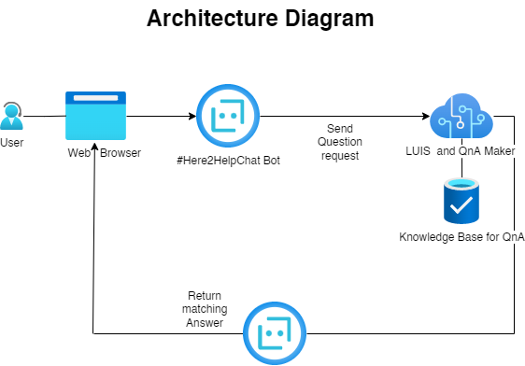

## Core Technologies

I have used various Azure Cognitive Services for building my project prototype.

### Azure QnA maker and Azure Bot Service

First, I have made a List of Question-and-Answer pairs of various Frequently Asked Questions (FAQ). This List is used to make the Knowledge base for the Assistant.

Secondly, added some personality to the Assistant using the Azure QnA Maker’s Chit-Chat Feature so that the bot could answer general questions.

Then I have trained the model with the help of Language Understanding so that the Assistant can understand the Natural Language inputted by the user.

Then I have deployed the Assistant to a Web App using the provided REST Endpoint and the Secret Keys so that client applications can access and interact with the Assistant on a website.

### Azure Speech Service

I have also used the Azure Speech Service to implement Text to Speech on the Website for people with disabilities.

I have used the Azure’s Neural text to speech voices which help in supplying high quality audio to the users on the website.

### A Focus on Accessibility

Since I am a visually impaired person, I feel the need for every website to be accessible for people with different abilities, so I have used the Bootstrap (CSS Framework) along with the various HTML 5 and ARIA (Accessible Rich internet Applications) to make the website accessible for people with different abilities.

### Bootstrap 5

Bootstrap 5 is one of the Leading CSS Framework used to create responsive Website using various pre-made components and libraries.

### HTML 5

HTML is the latest and most enhanced version of HTML.

### CSS

Cascading Style Sheets is a style sheet language used for describing the presentation of a document written in a markup language such as HTML. CSS is a cornerstone technology of the World Wide Web, alongside HTML and JavaScript.

## The Business Plan:

When I joined Senior College, I found it difficult to get answers to simple questions in the online world as I was not familiar with the college website. I explored few other college websites and observed that most websites do not have a proper FAQ page. In today’s world there are new modes of user interaction aided by Artificial Intelligence that would help in addressing the various repeated questions that both current and prospective students have.

## Competition

According to my research, many products and service-based companies have a full fledge FAQ page which list out he common Frequently Asked Questions. Along with this these websites also have a Chat Bot embedded on their website which helps the users to ask questions and get quick responses back. My AI based Chatbot aims to provide similar and a more inclusive/accessible solution to education and college websites.

## Business Model

My product can collaborate with many Colleges and schools to provide a personalized experience coupled with their own set of Questions and Answers.